**Website templates sources**

1. <https://wheniwork.com/>

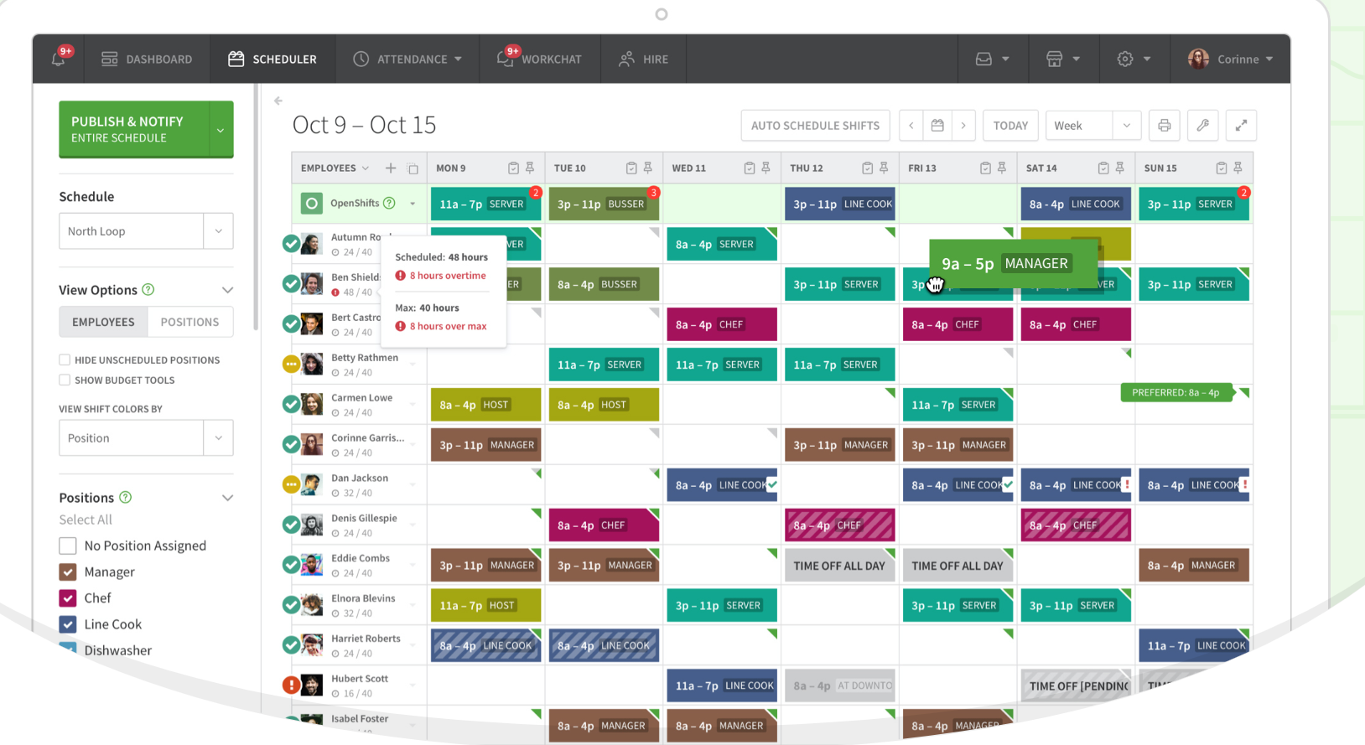

Parts that worked well: Too much function, too complex user interface.

Parts that did not work well: Colour on task is too dark.

2.<https://myduty.kr/>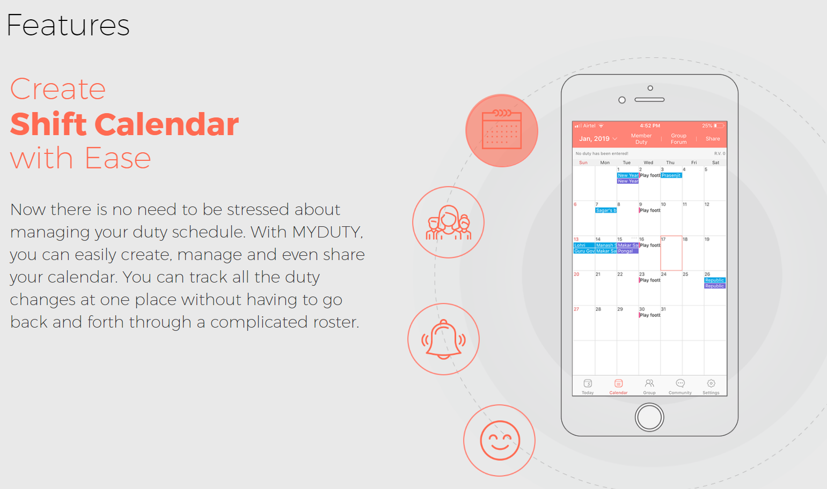

Parts that worked well: Clear design on the phone

Parts that did not work well: Colour on task showing is not clear and ugly.

3. <https://www.float.com/>

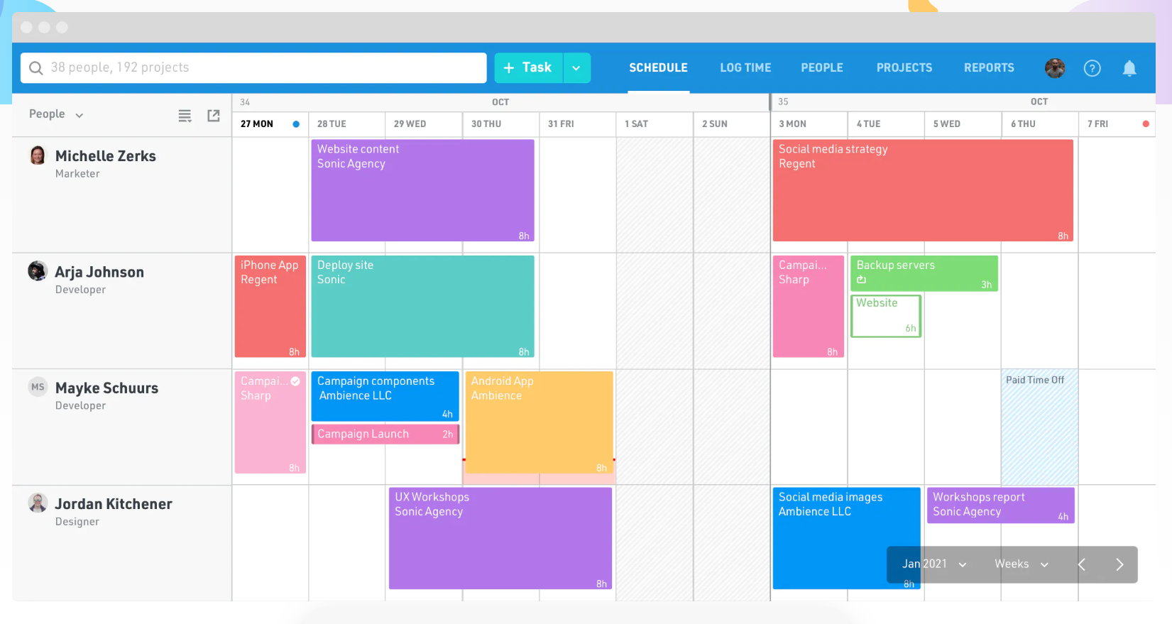

Parts that worked well: Nice colour theme

Parts that did not work well: Too much space leave for the side bar

4. <https://www.deputy.com/features/scheduling-software>

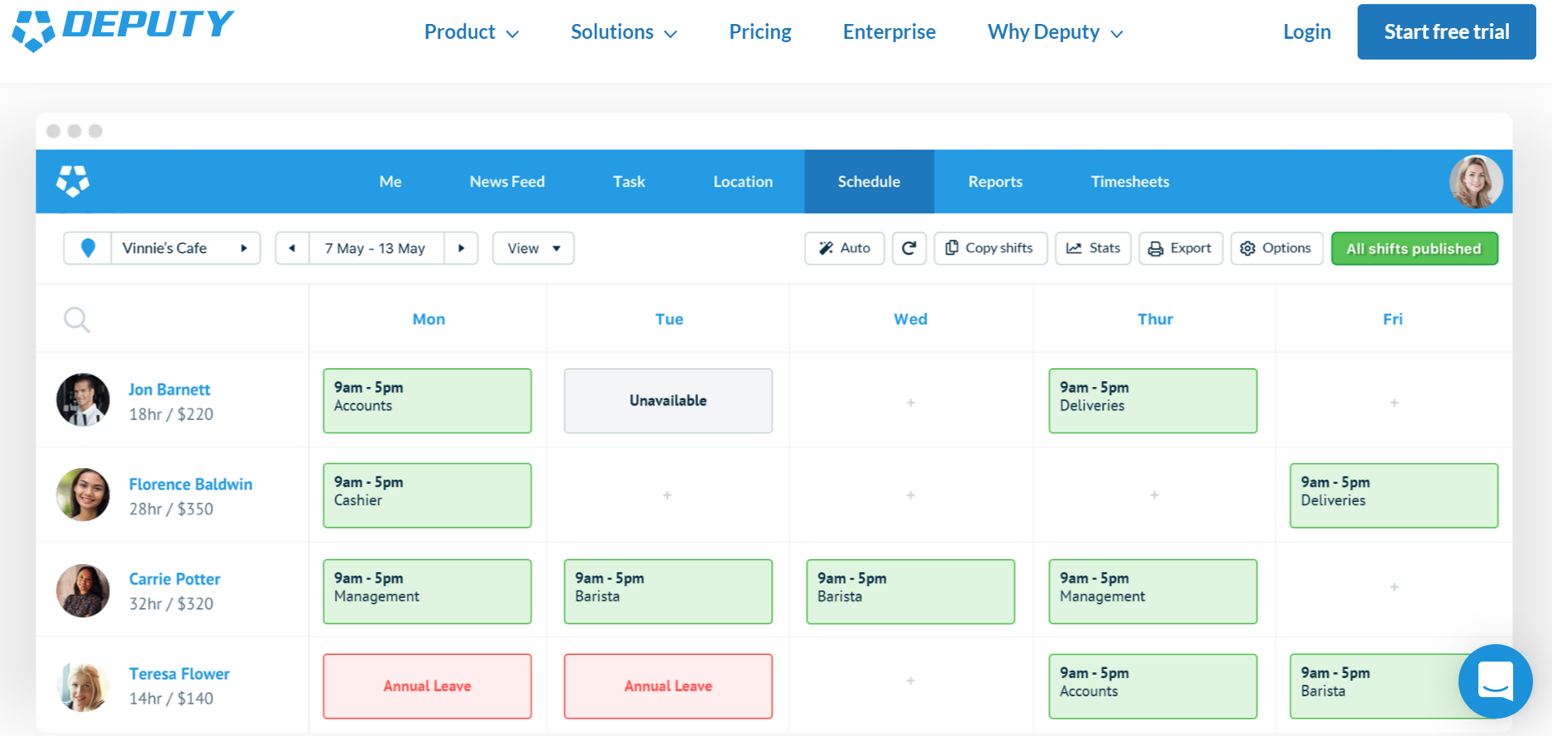

Parts that worked well: Very clear ui and nice try to weeks review

Parts that did not work well: Use the same colour on many task.

5. <https://lotsahelpinghands.com/>

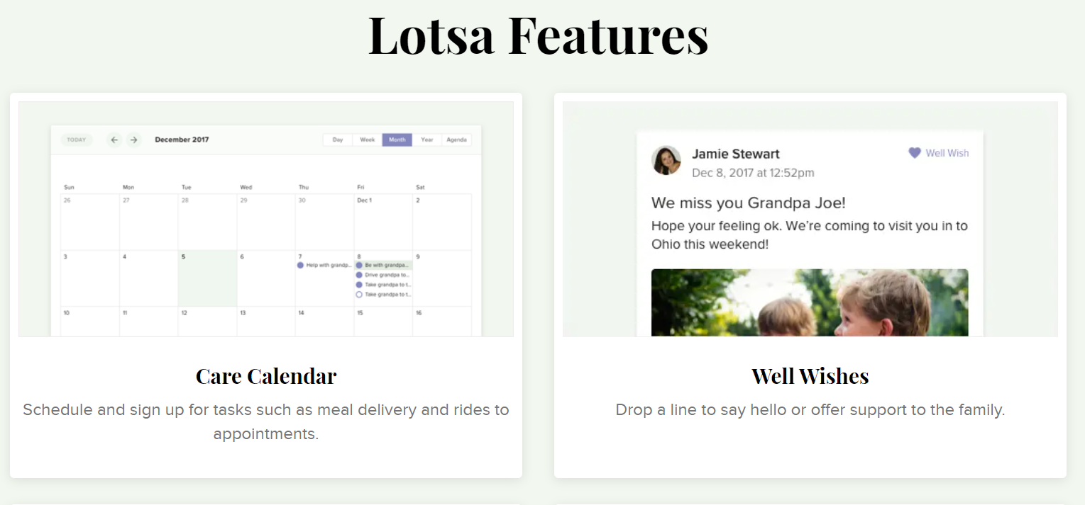

Parts that worked well: Nice colour theme

Parts that did not work well: Too few functions

6. <https://stafffox.com/>

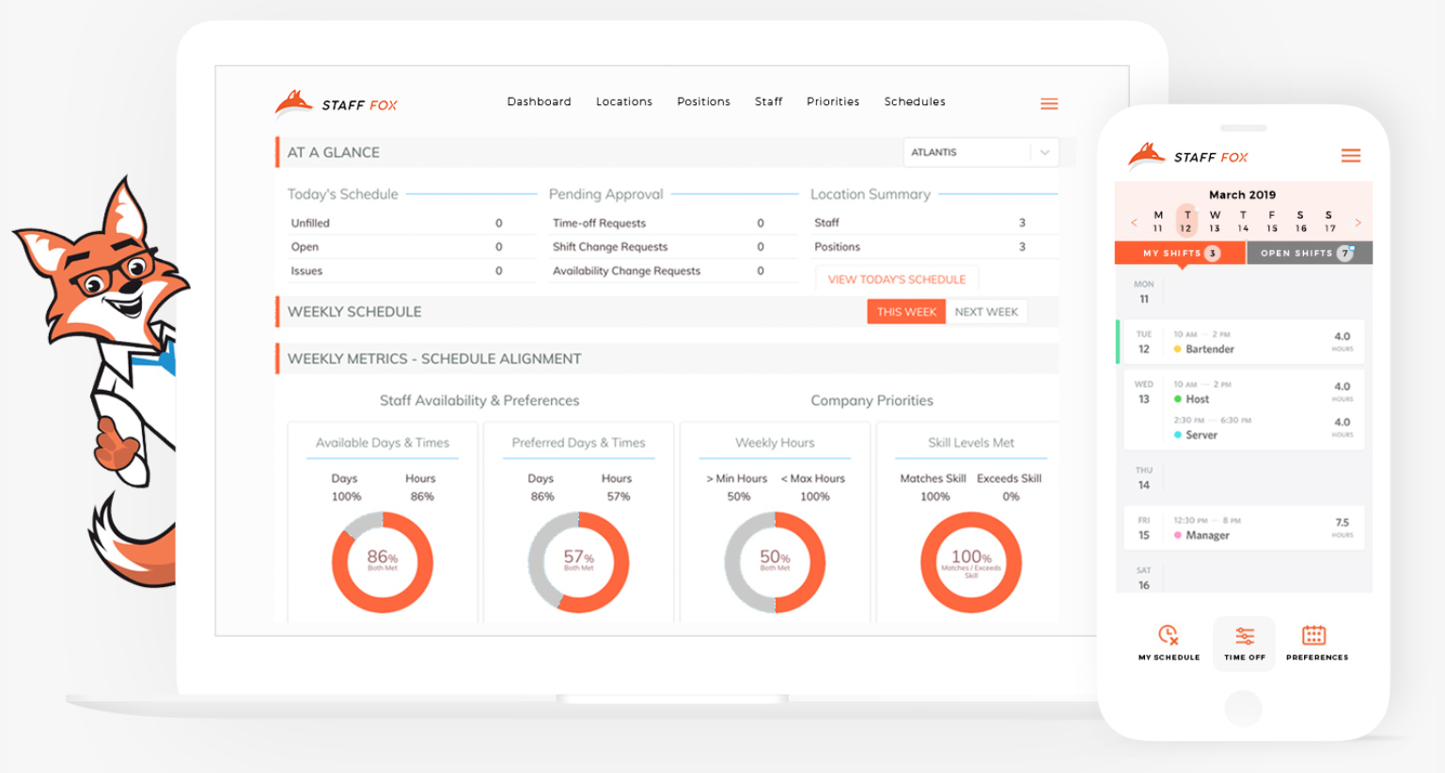

Parts that worked well: Clear view on the phone and graph chart.

Parts that did not work well: We do not need the staff member control function. Too few colour theme.